JSON FORMAT RESUME AND ITS LOOPS

# Resume in JSON format :

*let* harish_resume = {

    name: "Harish kumar M",

    age: 25,

    degree: 'mechanical engineering',

    year: 2019,

    college_name : 'Dr.NGPIT',

    course: " MERN FSD",

    technical_skills: {

        programming_lang: ["python", "js"],

        testing: ["manual", "jmeter", "automation"]

    },

    hobbies: ["volleyball ", 'reading', 'net surfing'],

}

console.log(harish_resume);

# Result :

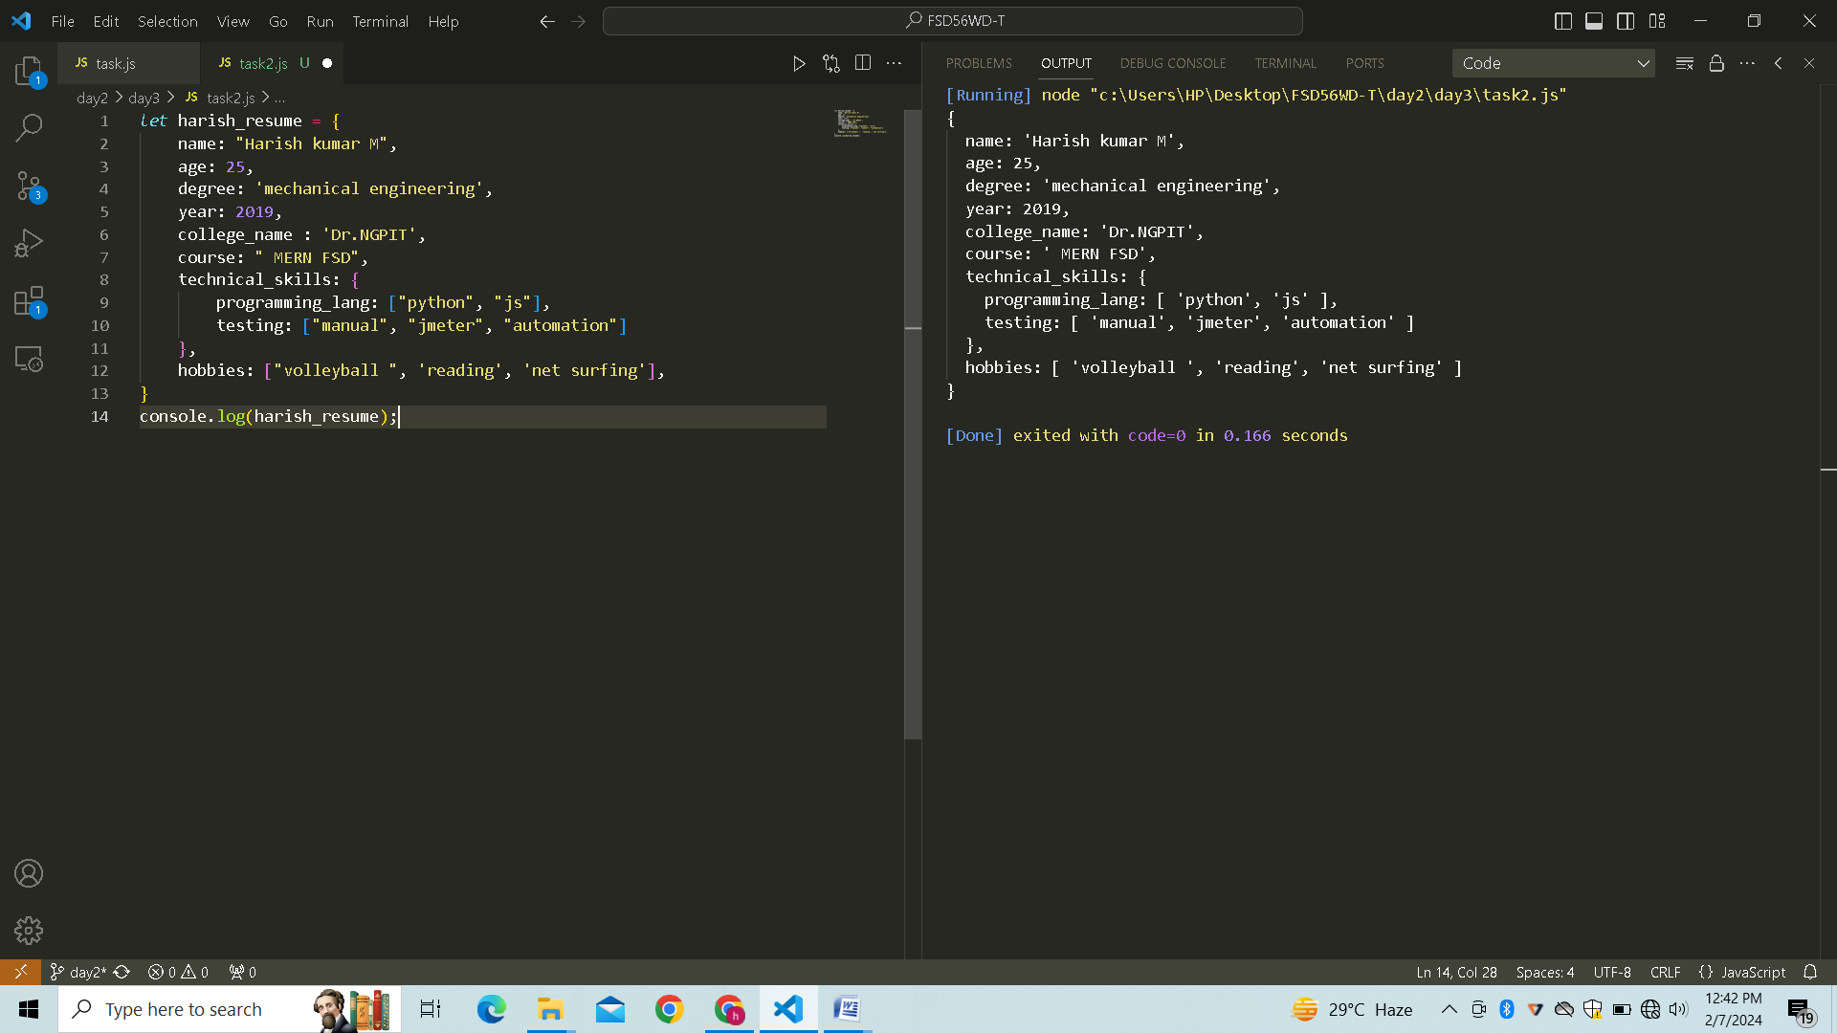

# For … in loop

*let* harish_resume = {

    name: "Harish kumar M",

    age: 25,

    degree: 'mechanical engineering',

    year: 2019,

    college_name : 'Dr.NGPIT',

    course: " MERN FSD",

    technical_skills: {

        programming_lang: ["python", "js"],

        testing: ["manual", "jmeter", "automation"]

    },

    hobbies: ["volleyball ", 'reading', 'net surfing'],

}

for (*let* x in harish_resume){

    console.log(x,':',harish_resume[x]);

}

# Result :

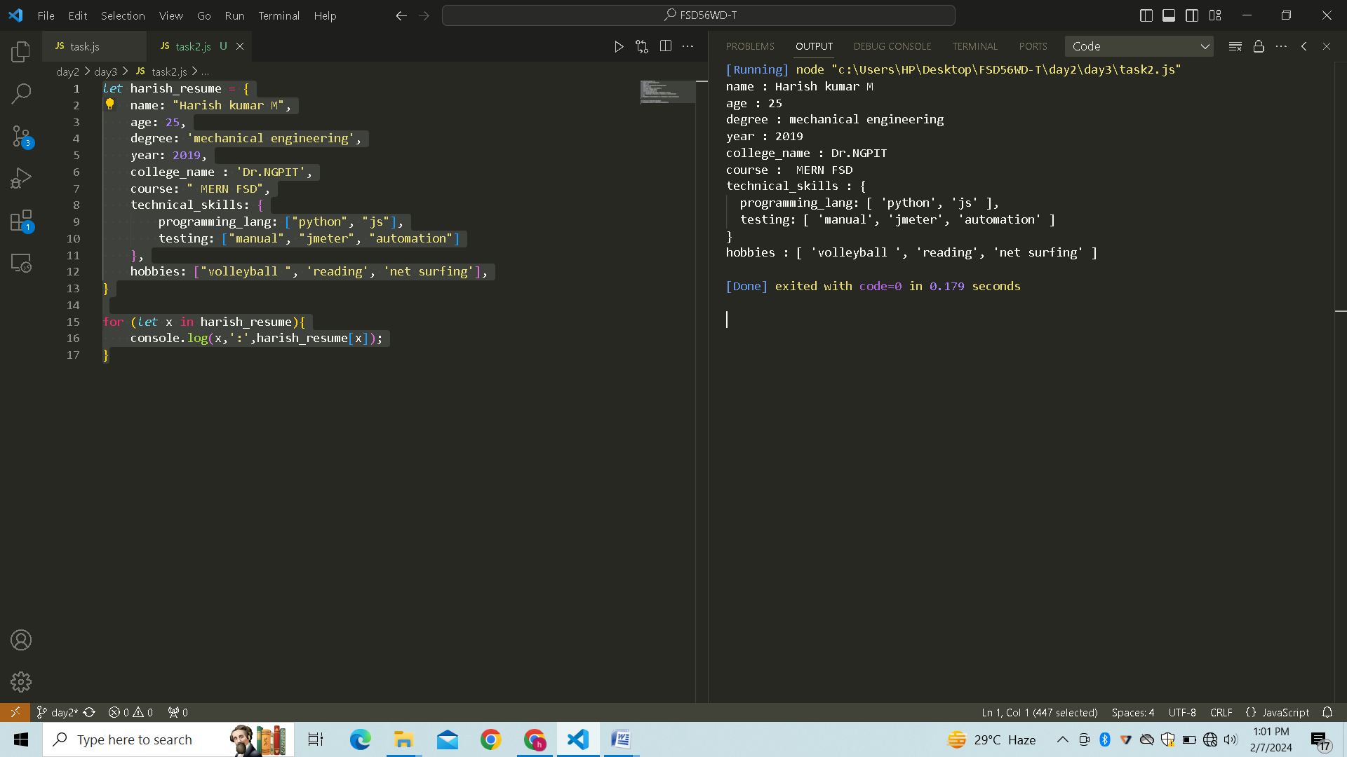

# For…. Loop

*let* harish_resume = {

    name: "Harish kumar M",

    age: 25,

    degree: 'mechanical engineering',

    year: 2019,

    college_name : 'Dr.NGPIT',

    course: " MERN FSD",

    skills : {

        technical :['c','c++','java'],

        soft : ['communication','behaviour']}

}

*let* entries =*Object*.entries(harish_resume)

for (*let* i=0;i<entries.length;i++){

*let* entry = (entries[i]);

    console.log(entry[0].toUpperCase(),':',entry[1]);

}

# Result :

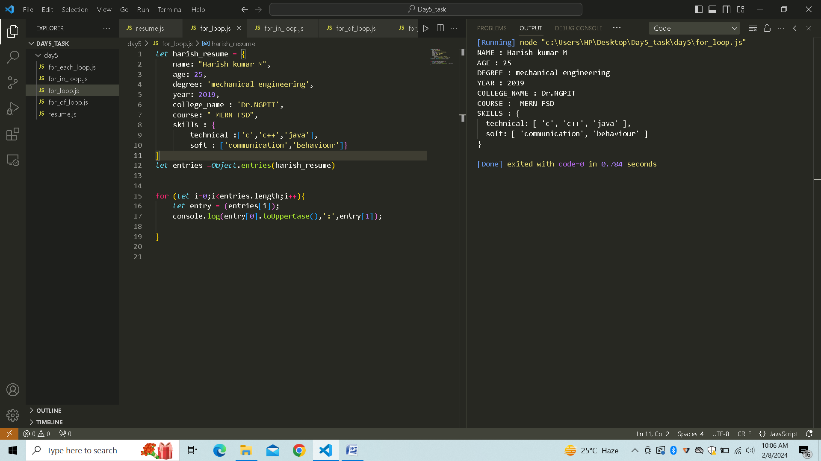

# For . . . of loop

*let* harish_resume = {

    name: "Harish kumar M",

    age: 25,

    degree: 'mechanical engineering',

    year: 2019,

    college_name : 'Dr.NGPIT',

    course: " MERN FSD",

    skills : {

        technical :['c','c++','java'],

        soft : ['communication','behaviour']}

}

*let* entries =*Object*.entries(harish_resume)

for (*let* entry of entries){

    console.log(entry[0].toUpperCase(),':',entry[1]);

}

# Result :

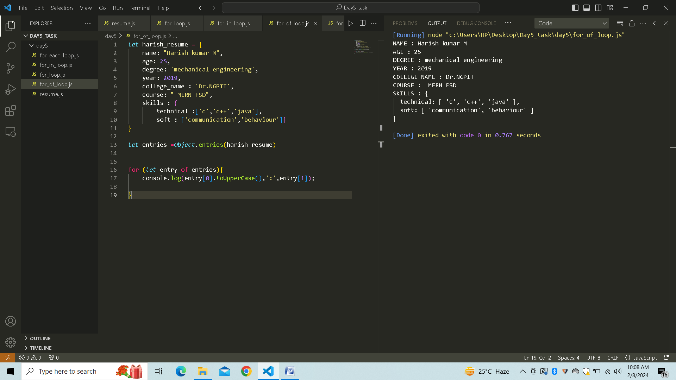

# For . . . each loop

*let* harish_resume = {

    name: "Harish kumar M",

    age: 25,

    degree: 'mechanical engineering',

    year: 2019,

    college_name : 'Dr.NGPIT',

    course: " MERN FSD",

    skills : {

        technical :['c','c++','java'],

        soft : ['communication','behaviour']}

}

*let* entries =*Object*.entries(harish_resume)

entries.forEach(*entry=>*{

    console.log(*entry*[0].toUpperCase(),':',*entry*[1]);

})

# Result :

